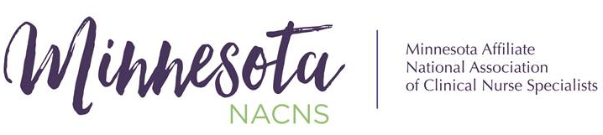
  - Volume 1 / Issue 4
President’s Corner
As 2023 comes to a close I’m reminded of many things I’m thankful for:
- The terrific group of people who agreed to serve alongside me on this year’s board.
- The fun, laughter, and discussions we shared as we worked hard to bring you events that hopefully made membership in this organization worthwhile for you.
- Members who also stepped up to help plan educational events.
- YOU who participated in the events that were offered.
- Those who planned inaugural “Give Back to Your Community” events during CNS week.
- The honor of serving as your president this year.

I congratulate and look forward to working with the newly elected board members who will join us in January 2024. A big thank you to departing board members Mary Gerchman-Smith, immediate past president, Lisa Douglas, treasurer, and Emily Gorzycki, student representative, for their dedicated service to support the mission and work of the MN NACNS.

Pam Schmidt, MS, APRN, ACNS-BC, CEN, PCCN

~ Pam Schmidt – 2023 President
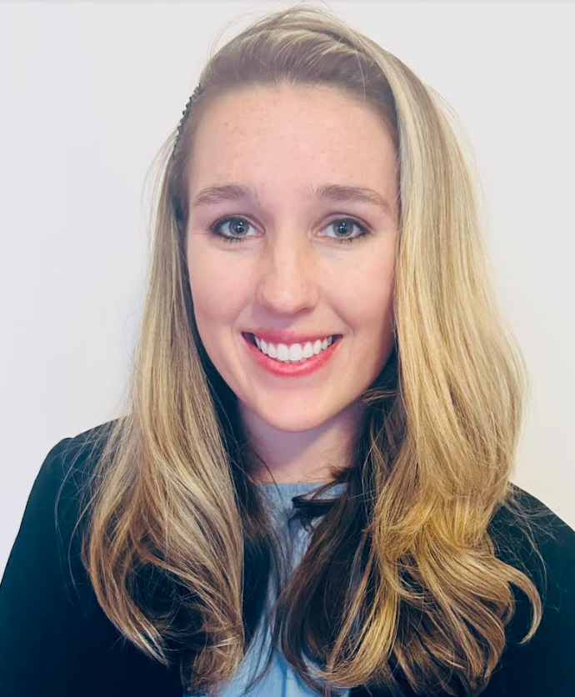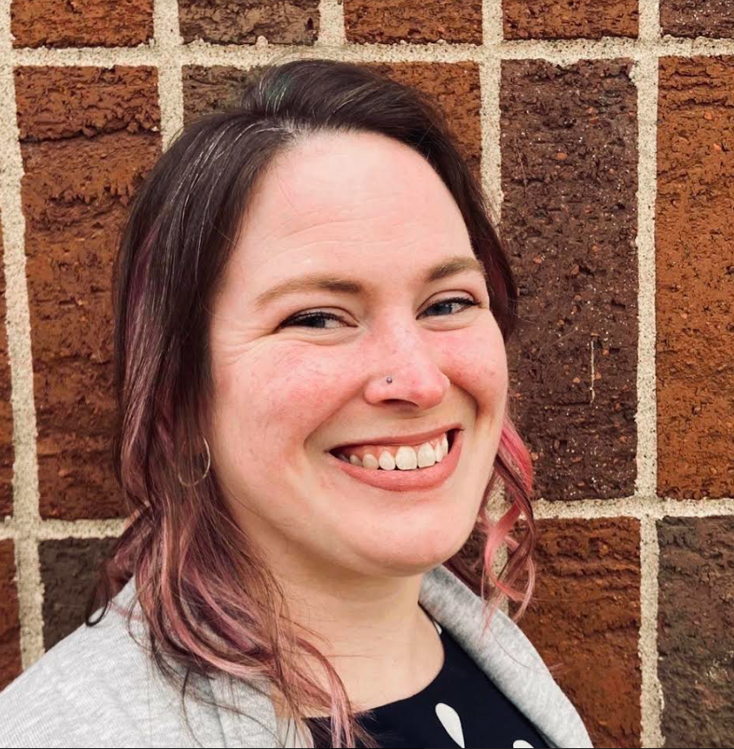
Emily Melanie Molly
Members of MN NACNS enjoying lunch

new MN NACNS Board Members
Congratulations and welcome to the following individuals on being elected to the 2024 MN NACNS Board.
President-Elect: Emily Stelter is an Adult-Gerontology Clinical Nurse Specialist with a Doctorate in Nursing Practice degree from the University of Minnesota. Her expertise stems from clinical roles spanning adult med-surg and orthopedic nursing including Staff Nurse, Charge Nurse, Preceptor, and Co-chair of an Adult Nursing Practice Council. She is currently practicing as a CNS at M Health Fairview in the role of a System Advanced Practice Registered Nurse supporting medical surgical and intermediate care areas.
Treasurer: Melanie Zell is an Advanced Practice Registered Nurse, Adult-Gerontology Clinical Nurse Specialist with a Master’s in Nursing Practice from the University of South Alabama. She has worked as a CNS at the University of Minnesota Medical Center since 2017, focusing on adult/gerontology acute care, respiratory care, enteral feeding, and general medical surgical nursing.
Student Representative: Mollie Meinhold is a Clinical Nurse Specialist student at the University of Minnesota and will graduate in the spring of 2026. While pursuing her graduate degree Mollie is working at Essentia Health, St. Mary’s Medical Center Duluth as a CNS intern. Mollie’s goal is to work for Essentia Health as the Critical Care CNS after graduation.

help needed – pharmacology conference
2024 is just around the corner and we need help planning the spring pharmacology conference. A chair and co-chair are essential, as well as committee members for the successful planning and implementation of the conference. If you are interested in participating, please email us at mncns.affiliate@gmail.com, by Friday, January 12, 2024. We know that many appreciate this opportunity to get essential pharmacology contact hours. If we do not have volunteers stepping forward, the pharmacology conference may not be offered.

MN NACNS BY-LAW CHANGES
The following updates were approved at the MN NACNS Annual Meeting on October 6, 2023:
- Article VII, section 3c: Added “start of the new calendar year” and deleted “close of the annual business meeting of the Association…”
- Article VIII, section 1b: Added “with an active status ( regular, student, senior or associate). To provide for effective planning, it is the expectation that members attend and participate in at least 75% of committee planning meetings.”
- Article VIII, section 1c: Added “and no more than 10.”
A full set of the by-laws can be reviewed at: MN NACNS - Bylaws

MN TITLE PROTECTION UPHELD
Shout-out to Melissa Thorson, MS, APRN, CCNS, CCRN (North Memorial) for notifying us of an error on the MN Department of Human Services (DHS) webpage! They had incorrectly identified us as “Certified Nurse Specialists” on their Minnesota Health Care Programs (MHCP) Enrollment page. Since we have title-protection per MN State Statute, Pam Schmidt, MN NACNS president, reached out directly to the MN DHS to get this error corrected. Their webpage has now been corrected and they’re working to correct our designation/title in their official Provider Manual in the next few weeks.
Please check out the Clinical Nurse Specialist Enrollment Criteria and Forms (urlisolation.com) link to see the importance of this clarification. FYI, here are links to the relevant statutes: Sec. 148.171 MN Statutes (urlisolation.com);
6305.0300 - MN Rules Part (urlisolation.com)
Without Melissa’s astute observation & timely notification to us, this error might have taken much longer to correct!

EDUCATIONAL OPPORTUNITIES
If you have a Minnesota-based educational opportunity you would like to share with colleagues, please submit the information to mncns.affiliate@gmail.com. Please note – the newsletter is published on a quarterly basis, so plan your submissions accordingly. Thanks!
Check out these upcoming conferences –
- Mayo Clinic Wound Symposium: The Edges of Wound Care being held February 28 – March 1, 2024.
- Trauma and Acute Care Surgery Symposium 2024 , May 15-18, 2024

MEMBER SPOTLIGHT
Congratulations to Emily Stelter, DNP, APRN, AGCNS-BC, on receiving the Rising Star Award from the University of Minnesota Alumni!

We want to hear from you. Each quarter we would like to highlight one of our members and the work he/she is doing related to nursing practice, education, or research. Please submit a brief (200 word) essay and photo of the work you have been doing to mncns.affiliate@gmail.com. This is available for both CNS and CNS students. Thank you!

COMING SOON
You will be receiving a survey from MN NACNS during the first week of January 2024. We are looking at our current affiliate membership numbers and seeking ways to better serve our current membership while also growing our organization. Watch your email for this vital survey and please fill it out ASAP!

QUESTIONS OR COMMENTS?
Email: mncns.affiliate@gmail.com Editor: Ronda Nading, 2023 President-Elect

